Dear Shareholders: January 1, 2014
On December 5, 2013 the Board of Directors presented a comprehensive overview of the Glen Oaks Village 2014 BUDGET. The presentation attended by many shareholders was an opportunity to learn in detail the spending plans and sources of revenue of our co-op. We have summarized the key points of the budget below and also prepared a small budget booklet that was handed out at the budget meeting and is available at the management office and at www.glenoaksvillage.com.
Keeping the co-op on SOLID FINANCIAL FOOTING and making decisions that positively impact the co-op is the essence of leadership and is what the Board of Directors does on a daily basis. As a result of higher Property Taxes, Water Rate increases, other rising costs and expected higher Union wages and benefits as the maintenance union Local 32BJ contract expires in April 2014, the Board has determined that a 3.75% MAINTENANCE INCREASE is necessary. This increase is the first one since 2012 and will cost most shareholders about $1 per day. It is not unreasonable to expect maintenance increases every other year as the city continues to impose increased costs and unfunded mandates on housing co-op budgets.
Glen Oaks Village still has the lowest maintenance of our neighboring co-ops and does not have a Flip Tax which many other co-ops have. A flip tax is a fee that apartment sellers must pay to the co-op upon sale of their unit. These flip tax fees can range from 10% to 50% of the revenue generated on a sale.
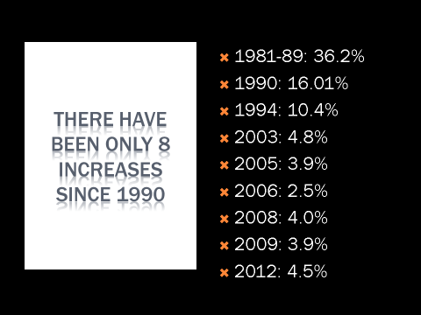
GLEN OAKS VILLAGE HAS A HISTORY OF LOW MAINTENANCE INCREASES. The volunteer Board whose members are not compensated and are subject to the same fees and maintenance as all shareholders, understands that there is never a good time for an increase. BUT A PROPERLY FUNDED BUDGET MUST REFLECT THE TRUE COST OF RUNNING A CO-OP.
Maintaining impeccable financials while also maintaining and upgrading the infrastructure of our 70 year-old buildings is essential and the 2014 Budget does just that. The Board understands an increase may be a hardship for some but it is only done as a last resort. Our history of low maintenance increases as seen here, confirms that.
2014 GLEN OAKS VILLAGE BUDGET SYNOPSIS
- 3.75% Maintenance Increase starting 1/1/14.
- STAR Credit Special Assessment. In order to be eligible for the STAR CREDIT offset, you will need to reapply for it by 12/31/13. We have previously sent out information about this and have a flyer with instructions available in the management office or online at www.glenoaksvillage.com.
- Windows Replacement fee will be imposed on NEW Buyers through 12/31/14.
- Garage Fees, Closing Fees, Parking Permit Fees and all other GOV Fees have NOT changed.
Thank you
Board of Directors

